October 18th. 2009
Hi
Finally, I have had a couple of days with nothing to do. All my writing for the Indonesian books is finished though there will still be a lot of proofreading to do for those books that are not yet completed. This past week I spent a day checking two units from the P5 book and two from the P6 book. There are still another 17 units to be done to complete these two books but this will be done after the trip to Indonesia. Books 3 and 4 are finished though I only have one copy of Book 3.
I will leave for Indonesia on November 5th or 6th, depending on whether or not I spend a night in Singapore on the way down, and return on November 15th. One week will be in Jakarta (as it was last year) and one day and two nights in Medan, way up in northwest Sumatra. In each place there will be an official launch of the P3-6 books for both Science and Maths and I will give 3-4 hour presentations in each place for the Science books. For some of the other days in Jakarta, I will visit schools that have adopted our books to carry out teaching workshops.
I think I will need to have a break from exercise for a week or so though will probably hang on and have this rest while in Indonesia. I am finding the aerobic exercise – running and swimming – very tough going at the moment.
On Wednesday, the Chief Executive delivered his annual policy address, what in the US would be called the ‘State of the Union’ address. No handouts as there were last year. In HK this week, a flat in mid levels was sold for – wait for it - $357 million (US$46 million)!! Imagine that, just for a flat, not a house and no garden. Though, at about 5000 sq ft, it is large and contains things such as a gym and Jacuzzi. Though the building is only about 40 storeys high, this flat was listed as being on the 66th floor. This is because the developers omitted many numbers for the floors so that they would include many ‘lucky’ numbers.
Saw on the TV news (several times), the incident of the young boy who was thought to be in a helium balloon as it floated across the Colorado countryside. Quite a chase. There was a suggestion that it was a publicity stunt but probably not.
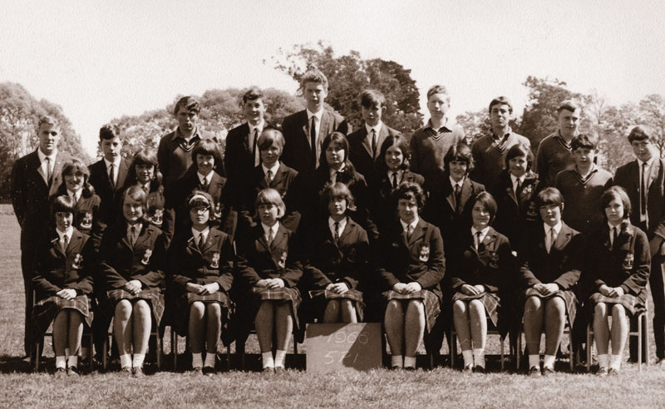
Yesterday, I received an e-mail from Uncle Bruce to give me the website for the 50th anniversary next Easter of Burnside High School. I was aware that there would probably be some celebration as the school began in 1960 as a typical secondary school and is now one of the largest in the country. I registered, though did not pay for anything just yet. I may attend it as I have not been to NZ for many years. The website is actually quite interesting and includes many class photos. Below is a photo of me with my form class, a Form 5 class in my last year at Burnside. Also, take a look at the picture of the current girls’ winter uniform with the kilt. I cannot believe that this is the current school ‘fashion’. It looks almost a 19th or early 20th century style with skirts right down to the ground. When I was at Burnside, it was the days of the min-skirt and there was a continual battle with many of the girls to keep their skirts to the required maximum of 2 cm above the knee (see picture again).

That’s about all there is for this week.
Cheers

